2. EC Clock
Kya hota hai?
Clock EC ka Heartbeat hai.
Clock ke bina EC execute hi nahi kar sakta.
Jaise CPU ko Clock chahiye hota hai,
waise hi EC ko bhi Clock chahiye.
Crystal
│
32.768KHz
│
▼
EC Clock
│
▼
EC CPU Run
Ya
25MHz Crystal
│
▼
EC Internal CPU

Clock ka kaam
Clock batata hai
"Next instruction kab execute karni hai."
Repairing me
Agar
- EC Supply OK
- EC Reset OK
lekin
Clock missing hai
to
- EC BIOS Read nahi karega
- Power Button respond nahi karega
- Power Sequence start nahi hogi

Main EC Requirements
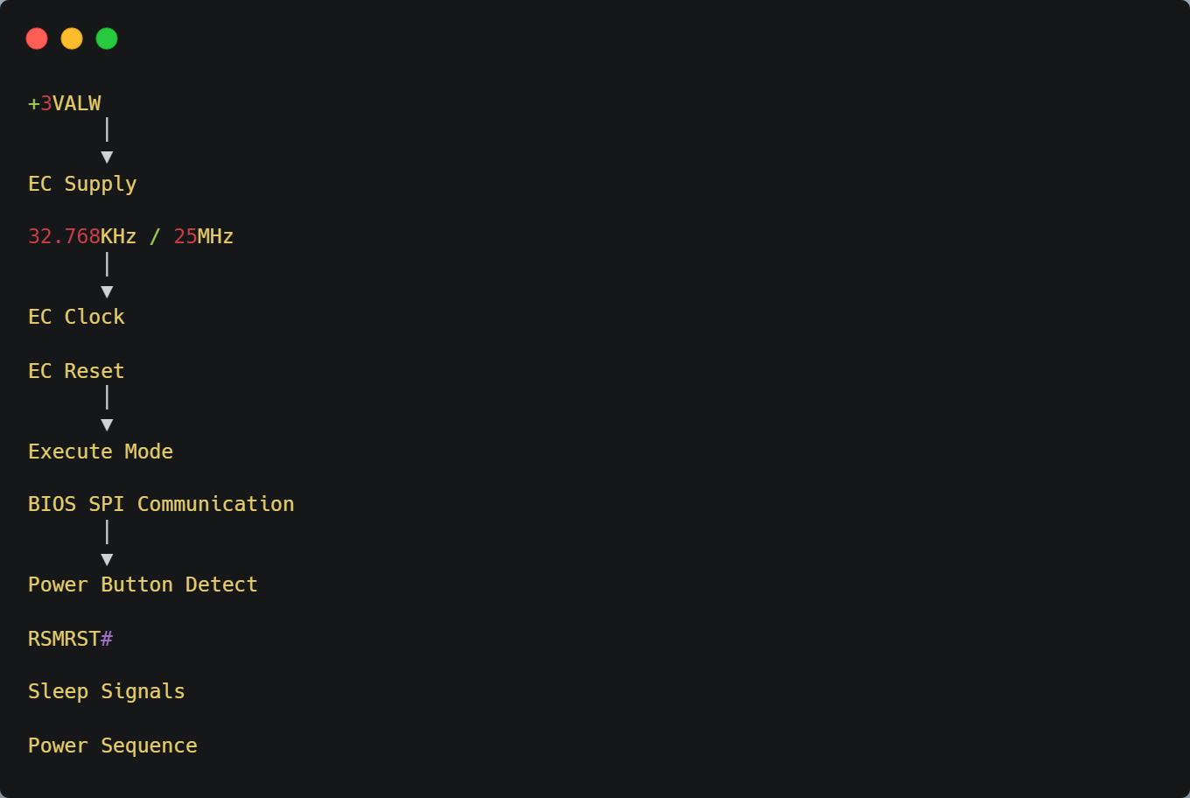

Schematic me search kare:
- XTAL
- X1
- X2
- Y1
- Y2
- EC_XIN
- EC_XOUT
- OSC

